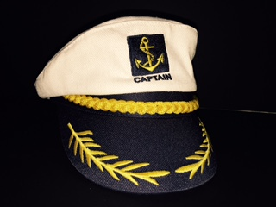
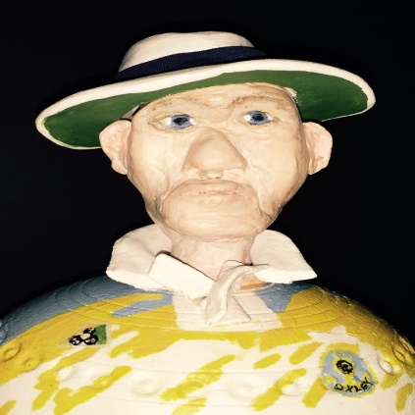
Oxley Bowling Club
Phone: 02 67663 449
Email: oxleybowlingclub@gmail.com
LIKE US ON FACEBOOK

PRESIDENT’S DAY
SUNDAY 25TH FEBRUARY 2018
TEAMS OF FOURS -- MIXED ACCEPTED
$100 PER TEAM
(includes Chinese lunch)
$100 Club plus Raffle
Cards called at 9.30am for a 10am start
RSVP by Friday 19th February
John Jennison
Phone 67607183 Mobile 0401524782
Peter Thomas 0428658094
CLUB Ph. 67663449

